EYFS Autumn Newsletter
I would like to take this opportunity to welcome back any returning children and greet any new children to our Early Years Unit. We have got lots of exciting things planned for the Autumn term and I can’t wait to get started! The first week has been brilliant, the children have settled into school so well and are picking up the routines very quickly.
Joint unit
As lots of you will know, we have a combined Nursery and Reception unit now. We have lots of things in place to ensure the progression between the year groups but please feel free to talk to myself if you have any questions.
Our staff
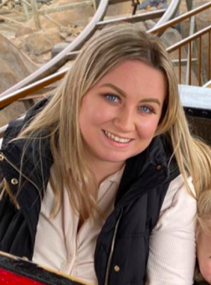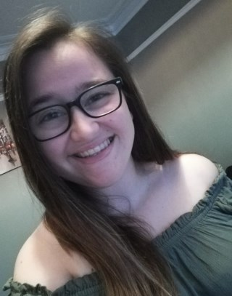
Miss Goodger Miss Nicolls Miss Smithurst
EYFS Lead & Teacher Teaching Assistant Teaching Assistant
Our Autumn Enquiry
Our Enquiry Question this term is: ‘What is the History within me?’. The children will learn about who they are, where they live, things about their families and how these things may have changed through History. It’s a very exciting time to learn about how we are unique and how we are all different.



Class Dojo
We use class dojo in school to communicate with families. This is where we will share notices and post pictures of what we have been doing. If you have not yet got a dojo account, please speak to myself and I can connect you.


Tapestry
We use an online learning journal called Tapestry. All children in our unit will have a personal online learning journal which records photos, observations and comments which build up a record of your child’s experiences during their time with us. It is a fantastic way of you seeing what your child is up to. If you have not got a tapestry account, please speak to myself and I can connect you.
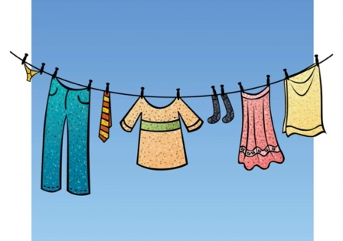
Spare clothing
We ask very kindly that your child always has spare trousers/skirts, socks, pants, tights, etc in their bag. If you have any old clothing that your child is growing out of, please donate it to school, we will be very grateful.

Reading books

All children now have a reading diary and book. We will read with your child in school and change books, please make sure they are always in your child’s bag. Whenever you read with your child, write it in their diary, the amount in which they read will go towards our school reading challenge.

PE

Our PE day this term is a Monday afternoon. Please could you send your child to school in the correct PE kit.
For PE all children need:
•Plain white T-shirt
•Navy/black PE shorts or track-suit bottoms (not leggings)
• Plimsolls/trainers
All PE kits should be free from any logo or brand name.

Thankyou for your continued support.
Kind regards,
Miss Goodger

