EYFS Spring Newsletter
Welcome back to the Spring term, we hope you had a lovely Christmas and New Year! We have a very exciting term planned with some lovely learning happening. In the first few days we were lucky to experience a visit from the fire service from Arnold. The children really enjoyed the time with the fire fighters looking at the truck, going inside, spraying the hose and trying on the clothing. It was a great opportunity to introduce our new enquiry for this term.
Our Spring Enquiry
Our Enquiry Question this term is: 'What is life like beyond Rise Park?'. The children will discover what life is like within their own community in preparation to build on this when learning about life beyond Nottingham in other countries such as India. They will learn what a community is and the people who help us in our community. This will then support them to discuss some similarities and differences between life in this country and life in other countries.
The aim will be to inspire and develop the children’s aspirations. The children will learn about the people who help and work within our community through the continuous provision.
Throughout the enquiry, the importance of diversity across these professions will be promoted e.g: race, gender. The children will be exposed to the community outside of their familiar environment and learn about how community connects us.
 Class Dojo
We use class dojo in school to communicate with families. This is where we will share notices and post pictures of what we have been doing. If you have not yet got a dojo account, please speak to myself and I can connect you.

Tapestry
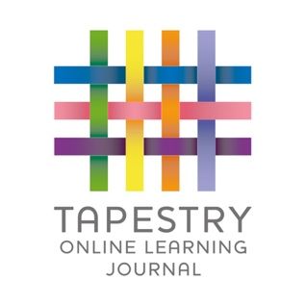
We use an online learning journal called Tapestry. All children in our unit will have a personal online learning journal which records photos, observations and comments which build up a record of your child’s experiences during their time with us. It is a fantastic way of you seeing what your child is up to. If you have not got a tapestry account, please speak to myself and I can connect you.

Reading books

We will read with your child in school and change books, please make sure they are always in your child’s bag. Whenever you read with your child, write it in their diary, the amount in which they read will go towards our school reading challenge.
PE

Our PE day this term is a Monday afternoon. Please could you send your child to school in the correct PE kit.
For PE all children need:
•Plain white T-shirt
•Navy/black PE shorts or track-suit bottoms (not leggings)
• Plimsolls/trainers
All PE kits should be free from any logo or brand name.

Thankyou for your continued support.
Kind regards,
Miss Goodger

