EYFS Summer Newsletter
Welcome back to the Summer term, we hope you had a lovely Easter break! We have a very exciting term planned with some lovely learning happening.
I would like to take this opportunity to welcome Mrs Liddiard to the team. Many of you will know Mrs Liddiard from working in the Foundation Unit a couple of years ago and more recently in Year One.
The Team:
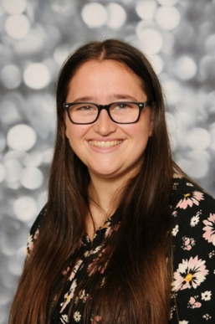

Miss Goodger (EYFS Lead) Miss Nicolls (TA) Mrs Liddiard (TA) Miss Smithurst (TA)
Our Summer Enquiry
Our Enquiry Question this term is: How do we look after our world?'. We will look into a variety of subjects regarding what happens in the world around us and what we can do to help look after it. We begin our enquiry with growing, the children will learn what a plant needs to grow and have the opportunity to plant their own seeds. We then move into life cycles and focus mainly on caterpillars and butterflies. We are so lucky to have our own caterpillars to look after and watch their transformation.
Moving into the second half of the term the children will learn about what is happening to our world and the homes of animals. We will discuss what we can do to support and try out a variety of things including making bug hotels and recycling plastic.
 Class Dojo
We use class dojo in school to communicate with families. This is where we will share notices and post pictures of what we have been doing. If you have not yet got a dojo account, please speak to myself and I can connect you.


Tapestry
We use an online learning journal called Tapestry. All children in our unit will have a personal online learning journal which records photos, observations and comments which build up a record of your child’s experiences during their time with us. It is a fantastic way of you seeing what your child is up to. If you have not got a tapestry account, please speak to myself and I can connect you.
Reading books
We will read with your child in school and change books, please make sure they are always in your child’s bag. Whenever you read with your child, write it in their diary, the amount in which they read will go towards our school reading challenge.
PE

Our PE day this term is a Monday afternoon. Please could you send your child to school in the correct PE kit.
For PE all children need:
•Plain white T-shirt
•Navy/black PE shorts or track-suit bottoms (not leggings)
• Plimsolls/trainers
All PE kits should be free from any logo or brand name.

Thankyou for your continued support.
Kind regards,
Miss Goodger

