Tuesday 16th November 2021
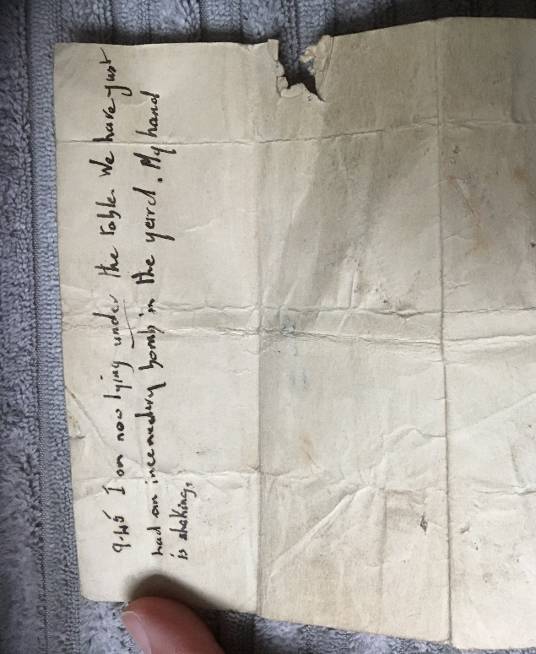
We re-enacted a WW2 battle experiencing bombs, air raids, the fall of our commanding officer and supporting wounded comrades. We also received a letter which was written during WW2 by a woman to her friend serving on the front line, sadly the letter was never sent as her house was bombed minutes after her last sentence…

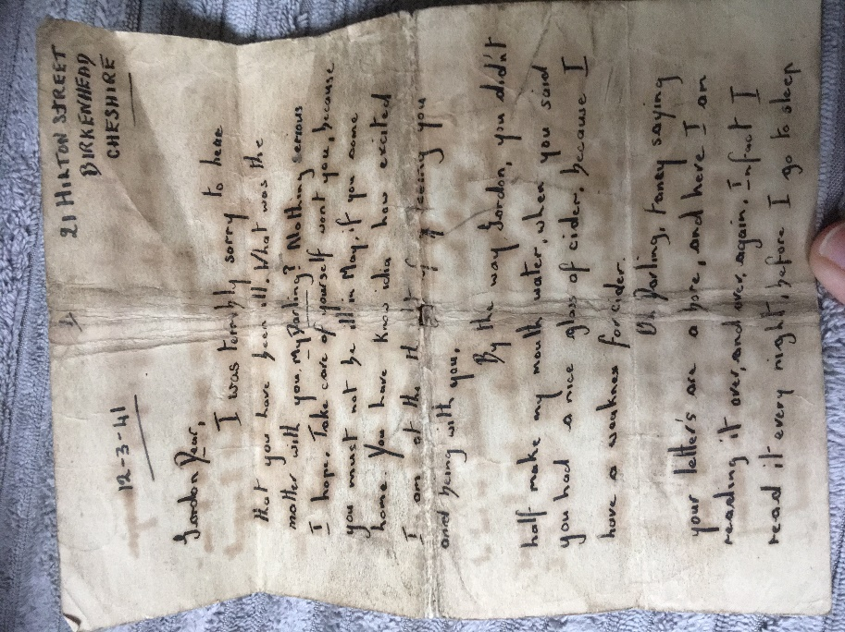

This is the first page and last page of her letter…


